INTERNSHIP REPORT ON

EDUPHOENIX SOLUTIONS


Submitted to Bengaluru City University

In partial fulfillment for the award of B. Com
Degree by

REG NO:

Faculty
DR.
ASSOCIATE PROFESSOR
Department of Commerce
GOVERNMENT RAMNARAYAN CHELLARAM COLLEGE OF COMMERCE AND MANAGEMENT
(Affiliated to Bengaluru City University)

PALACE ROAD, BENGALURU-560 001
EVALUATION OF INTERNSHIP REPORT
For submission to Bengaluru City University

Student | Mentor/Supervisor
Name: STUDENT NAME | Name:
Reg No: | Signature:
Signature: | Signature:
Date: | Date:

 | Project | Viva-Voce | Total
Max. Marks | 60 | 40 | 100
Marks. Allotted
Name of examiner |  | Sign:
Evaluation Summary

INTERNSHIP CERTIFICATE


GOVERNMENT RAMNARAYAN CHELLARAM COLLEGE
OF COMMERCE AND MANAGEMENT
( Affiliated to Bengaluru City University )
PALACE ROAD, BENGALURUN-560001

COLLEGE CERTIFICATE

This is to certify that Mr. STUDENT NAME bearing Reg.no.,UUCMS ID: . is a student of VI SEM B.COM of our College.
He has prepared Internship report entitled “An Internship overview on FINANCE at EduPhoenix Solutions, RT Nagar” from 21/08/2024 to 21/09/2024 towards the partial fulfilment of the requirement of Bachelors of Commerce Degree of Bengaluru North University

PLACE: PRINCIPAL
DATE: Dr. B Chandrashekar

STUDENT DECLARATION

I STUDENT NAME., Reg. No. UUCMS Id: , hereby declare that this report entitled “An Internship overview on FINANCE at EduPhoenix Solutions, RT Nagar” during the summer vacation between the period from 21-08-2024 to 21-09-2024 at EduPhoenix Solutions, RT Nagar” under the supervision and guidance of Dr. M.Krishnappa, Associate professor of Commerce, Government Ramnarayan Chellaram College Of Commerce And Management

Place: Name of the Student
Date: STUDENT NAME
ACKNOWLEDGEMENT

The successful completion of this internship report required significant guidance and assistance from many individuals, and I am truly grateful for their support throughout this journey.
Firstly, I would like to express my sincere appreciation to Mr. Garvit Garg, who provided me with the invaluable opportunity to intern at EduPhoenix Solutions. His guidance and mentorship were instrumental in my professional development and learning experience during this internship.
I am also deeply grateful to our faculty coordinator, Mr. [Name], and our principal, Dr. B Chandrashekar , for their unwavering support and for granting me the valuable opportunity to intern, which has been pivotal in my exposure to the field of digital marketing.
I would like to extend my heartfelt thanks to my parents for their permission and constant encouragement throughout this internship. Additionally, I am thankful to my friends for their support whenever I needed their assistance during this project.
Lastly, I would like to express my profound gratitude to all individuals who directly or indirectly contributed to the completion of this report.

TABLE OF CONTENTS

Chapter No. |  | Title | Page No.
 | CERTIFICATE OF INTERNSHIP |  | i
 | COLLEGE CERTIFICATE |  | ii
 | STUDENT DECLARATION |  | iii
 | ACKNOWLEDGEMENT |  | iv
 | TABLE OF CONTENTS |  | v
1 |  | Company | 1
2 |  | Domain: FINANCE | 18
3 |  | Internship Tasks/ Daily logs | 30
4 |  | Project | 35
5 |  | Career Opportunities | 40
6 |  | Future Trends | 42
7 |  | Conclusion | 44
8 |  | References | 45
Annexures
- Log Sheet
- Any Other (given by company)

CHAPTER 1
COMPANY
  - Company Profile
EduPhoenix Solutions is a dynamic and innovative company dedicated to providing cutting-edge solutions in the field of education technology. Established with a vision to revolutionize learning experiences, EduPhoenix Solutions offers a comprehensive range of products and services tailored to meet the evolving needs of educational institutions, students, and educators.
At EduPhoenix Solutions, we leverage the latest advancements in technology to develop intuitive and interactive educational platforms, tools, and resources. Our team of experts is committed to designing and delivering solutions that enhance teaching effectiveness, engage learners, and foster academic success.
From e-learning platforms and virtual classrooms to customized educational software and mobile applications, EduPhoenix Solutions offers a diverse portfolio of products aimed at transforming traditional learning paradigms. We prioritize user-centric design, ensuring that our solutions are user-friendly, accessible, and adaptable to diverse learning environments.

Figure 1.1 Company Logo
In addition to our innovative products, EduPhoenix Solutions provides consultancy services, training programs, and ongoing support to help educational institutions maximize the impact of technology on teaching and learning outcomes. Our collaborative approach enables us to work closely with clients to understand their unique challenges and goals, delivering tailored solutions that drive positive change and innovation.
EduPhoenix Solutions stands at the forefront of educational technology, driven by a passion for innovation and a commitment to excellence. With a deep understanding of the challenges facing modern educational institutions, we offer a comprehensive suite of solutions designed to elevate teaching and learning experiences to new heights.
Our team of experts combines extensive experience in both education and technology to develop cutting-edge platforms and tools that empower educators and engage learners. By harnessing the latest advancements in artificial intelligence, data analytics, and user-centric design, we create intuitive and immersive learning environments that foster creativity, critical thinking, and collaboration.
Beyond our innovative products, EduPhoenix Solutions provides strategic consultancy services and professional development programs to support educational institutions in leveraging technology effectively. From needs assessment and solution design to implementation and ongoing support, we partner with our clients every step of the way to ensure the success of their digital initiatives.
With a strong focus on user experience, accessibility, and scalability, our solutions are tailored to meet the unique needs of diverse educational settings, from K-12 schools to higher education institutions and corporate training programs. By delivering customizable, adaptable, and future-ready solutions, we empower educators to deliver high-quality instruction and empower learners to achieve their full potential in an increasingly digital world.
Driven by a shared vision of transforming education through technology, EduPhoenix Solutions is dedicated to pushing the boundaries of innovation and driving positive change in the education landscape. As we continue to evolve and expand our offerings, we remain steadfast in our commitment to delivering impactful solutions that inspire lifelong learning and shape the future of education.
With a commitment to excellence, integrity, and continuous improvement, EduPhoenix Solutions is dedicated to empowering educators, inspiring learners, and shaping the future of education through technology. We are proud to partner with educational institutions worldwide, helping them unlock the full potential of digital learning in the 21st century.

1.2 Company Overview
EduPhoenix Solutions is a dynamic and forward-thinking company that specializes in providing innovative educational technology solutions to institutions worldwide. Established with a vision to revolutionize the way education is delivered and experienced, EduPhoenix Solutions has quickly emerged as a leader in the field, offering a wide range of cutting-edge products and services tailored to meet the diverse needs of educators and learners alike.
At EduPhoenix Solutions, we believe that technology has the power to transform education by making learning more accessible, engaging, and effective. With this belief at the core of our mission, we strive to develop solutions that empower educators to deliver high-quality instruction and enable learners to reach their full potential.
Our comprehensive suite of products and services encompasses everything from learning management systems and virtual classrooms to interactive content authoring tools and professional development programs. Whether it's providing educators with the tools they need to create immersive learning experiences or offering learners access to dynamic and interactive learning environments, EduPhoenix Solutions is committed to driving positive change in education through technology.
One of the key strengths of EduPhoenix Solutions lies in our team of experts, who bring a wealth of experience and expertise from diverse fields such as education, technology, instructional design, and user experience. By combining our knowledge and skills, we are able to develop innovative solutions that address the evolving needs of the education sector and deliver measurable results.
In addition to our product offerings, EduPhoenix Solutions also provides consultancy services to educational institutions seeking to leverage technology effectively. From needs assessment and solution design to implementation and ongoing support, our team works closely with clients to develop customized strategies and solutions that align with their unique goals and objectives.
As a company, we are deeply committed to excellence, integrity, and customer satisfaction. We take pride in our ability to deliver high-quality products and services that meet the highest standards of quality and reliability. With a customer-centric approach and a focus on continuous improvement, we strive to exceed our clients' expectations and build long-lasting partnerships based on trust and mutual respect.

  - Company Departments
EduPhoenix Solutions operates across several departments, each contributing to the overall mission of delivering innovative educational solutions and services. These departments include:

Human Resources (HR) Department:
Recruitment and Talent Acquisition: This involves identifying staffing needs, sourcing candidates through job postings and recruitment agencies, conducting interviews, and selecting the best-fit candidates.
Employee Onboarding and Orientation: HR ensures that new hires receive necessary training, complete required paperwork, understand company policies, and integrate smoothly into their roles and the organization.
Performance Management: HR oversees performance evaluations, goal setting, feedback mechanisms, and recognition programs to foster employee growth, development, and engagement.
Employee Relations: This department handles employee grievances, conflicts, disciplinary actions, and ensures compliance with employment laws and regulations.
Training and Development: HR designs and implements training programs, workshops, and seminars to enhance employee skills, competencies, and professional development opportunities.

Figure 1.3.1 Functions of Human Resources (HR)

Information Technology (IT) and Technical Support Department:
Infrastructure Management: This includes managing servers, networks, hardware, and software systems to ensure seamless operation, security, and scalability.
Systems Administration: IT administrators monitor system performance, troubleshoot technical issues, install updates, and ensure data backups and recovery protocols are in place.
Cybersecurity: This team protects the organization from cyber threats by implementing firewalls, antivirus software, intrusion detection systems (IDS), and conducting regular security audits and assessments.
Software Development: IT professionals develop and maintain custom software applications, websites, and digital platforms to support internal operations and customer-facing solutions.
Technical Support: The IT helpdesk provides technical assistance, resolves user issues, and offers guidance on software usage, hardware configuration, and network connectivity.
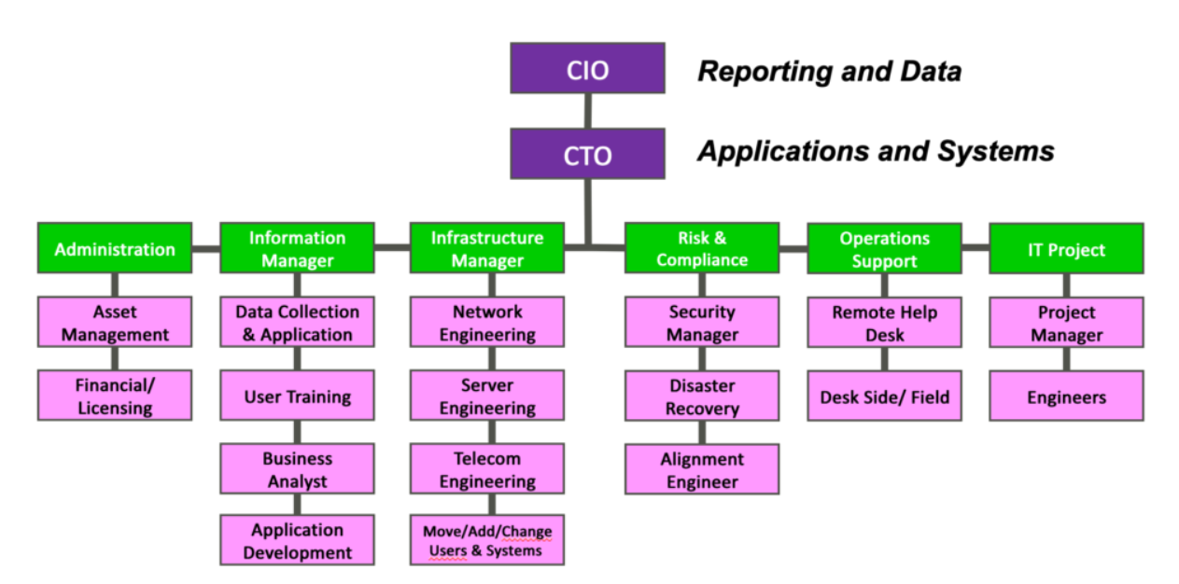
Figure 1.3.2 Information Technology (IT) Department Structure

Research and Development (R&D) Department:
Market Research and Analysis: R&D conducts market research to identify industry trends, customer preferences, and competitive landscapes to inform product development strategies.
Product Innovation: This team conceptualizes and prototypes new products, features, and services, leveraging emerging technologies and customer feedback to drive innovation.
Prototype Development: R&D builds and tests prototypes to validate concepts, assess feasibility, and gather user feedback before full-scale development and commercialization.
Intellectual Property Management: This involves securing patents, trademarks, and copyrights to protect the organization's innovations, inventions, and creative works from infringement.
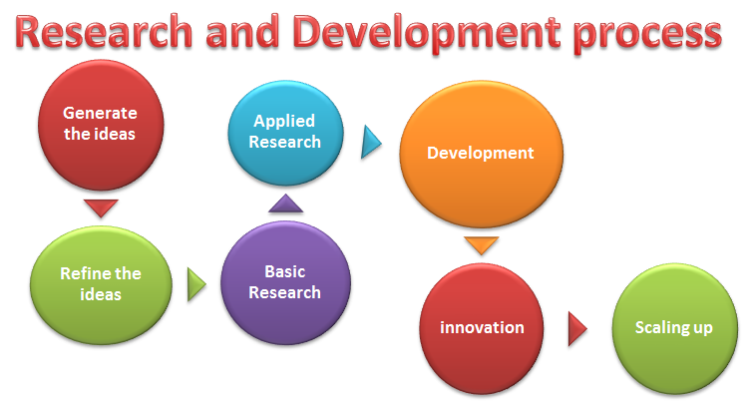
Figure1.3.3 Research & Development Process

Sales and Marketing Department:Market Segmentation and Targeting: Sales and marketing professionals identify and segment target markets based on demographics, behaviors, and preferences to tailor marketing messages and campaigns.
Lead Generation and Nurturing: This team generates leads through advertising, content marketing, and networking efforts, then nurtures those leads through email campaigns, follow-up calls, and personalized communication.
Brand Management: Sales and marketing professionals develop brand identity, messaging, and positioning strategies to differentiate EduPhoenix Solutions from competitors and build brand loyalty.
Digital Marketing: This involves leveraging digital channels such as websites, social media platforms, search engine optimization (SEO), and pay-per-click (PPC) advertising to reach and engage target audiences.
Sales Enablement: Sales enablement teams provide sales reps with the tools, resources, and training needed to effectively communicate product features, benefits, and value propositions to prospects and customers.

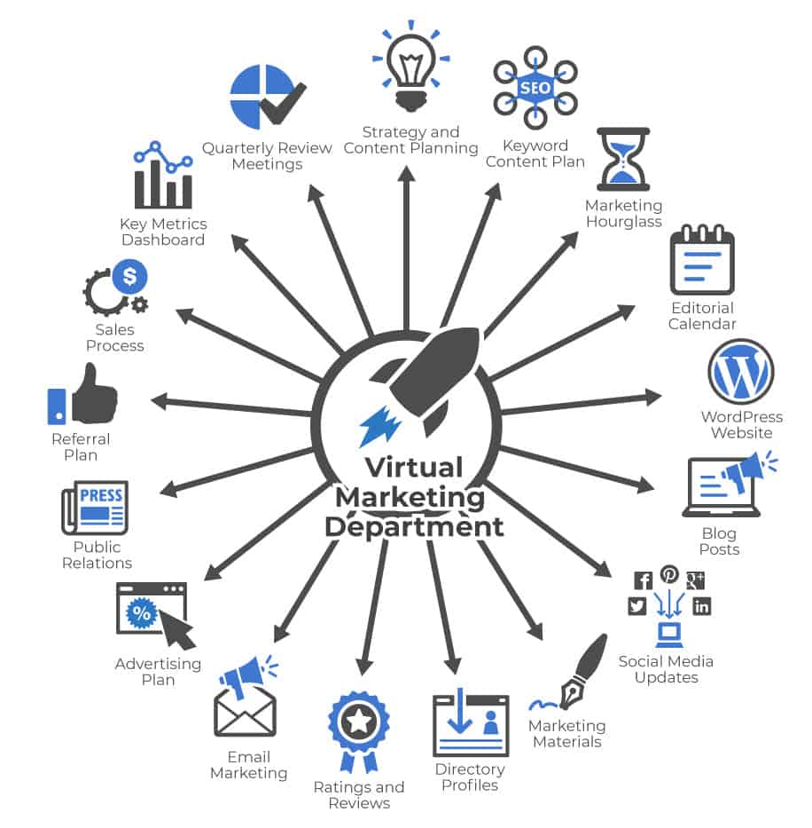

Figure 1.3.4(a) Virtual Marketing  Department | Figure 1.3.4(b) Marketing  Department

Customer Success Department:

Customer Onboarding: This involves guiding new customers through the implementation process, providing training, support, and resources to ensure successful adoption and utilization of EduPhoenix Solutions.
Figure 1.3.5 Customer Success
Customer Relationship Management: Customer success managers build and nurture relationships with clients, acting as their advocate within the organization and ensuring their needs and expectations are met.
Account Management: This team is responsible for managing customer accounts, identifying upsell and cross-sell opportunities, and fostering long-term relationships to drive retention and expansion.
Customer Support: The customer support team provides responsive assistance, troubleshooting, and issue resolution to address customer inquiries, technical challenges, and service disruptions effectively.

Finance and Accounting Department:
Financial Planning and Analysis: This department is responsible for budgeting, forecasting, financial modeling, and providing insights to support strategic decision-making.
Accounts Payable and Receivable: Finance professionals manage payments to vendors, invoicing customers, and tracking receivables to ensure timely cash flow management.
Financial Reporting and Compliance: This team prepares financial statements, regulatory filings, and ensures compliance with accounting standards, tax laws, and industry regulations.
Treasury Management: Finance professionals oversee cash management, investment strategies, and risk mitigation to optimize liquidity and financial stability.

Figure 1.3.6 Finance & Accounting

Legal and Compliance Department:
Contract Management: Legal professionals draft, review, and negotiate contracts with clients, partners, and vendors to protect EduPhoenix Solutions' interests and mitigate legal risks.
Regulatory Compliance: This team ensures compliance with laws, regulations, and industry standards related to data privacy, security, intellectual property, and consumer protection.
Intellectual Property (IP) Management: Legal experts manage EduPhoenix Solutions' intellectual property portfolio, including patents, trademarks, copyrights, and trade secrets.
Risk Management: The legal and compliance department identifies, assesses, and manages legal and regulatory risks to minimize exposure and protect the organization from liabilities.
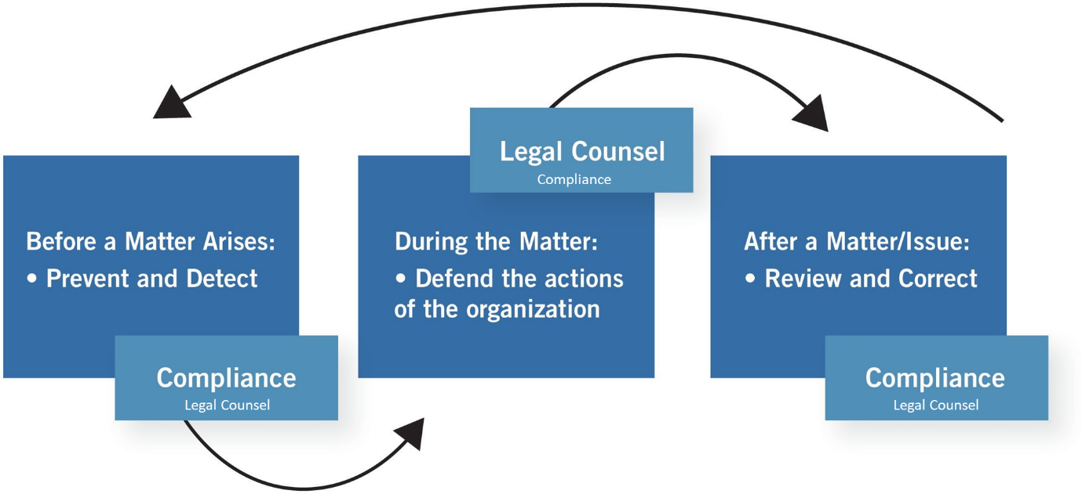
Figure 1.3.7 Legal & Compliance Procedure

Operations and Logistics Department:
Supply Chain Management: Operations professionals oversee procurement, inventory management, and logistics to ensure timely delivery of goods and services while optimizing costs and efficiency.
Facilities Management: This team maintains and manages office facilities, equipment, and infrastructure to create a safe, productive, and comfortable work environment.
Quality Assurance and Control: Operations experts develop and implement quality standards, processes, and metrics to ensure products and services meet or exceed customer expectations.

Figure 1.3.8(a) Operations  Management | Figure 1.3.8(b) Logistics

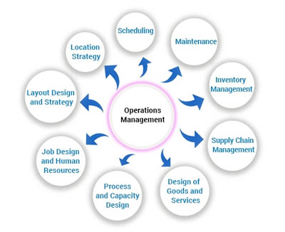

Project Management: Operations professionals coordinate cross-functional projects, allocate resources, and track progress to ensure timely completion and successful outcomes.

Customer Experience Department:
User Experience (UX) Design: This team focuses on designing intuitive, user-friendly interfaces and interactions for digital products and platforms to enhance customer satisfaction and engagement.
Customer Insights and Analytics: CX professionals analyze customer feedback, behavior data, and performance metrics to gain actionable insights and drive continuous improvement initiatives.
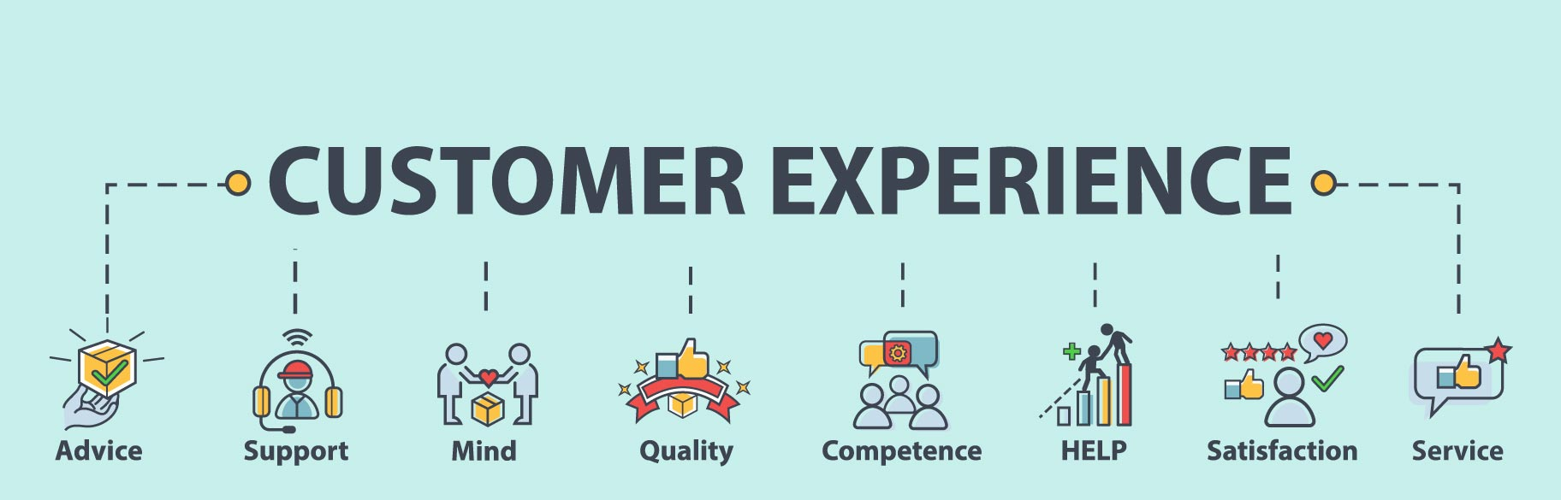
Customer Advocacy: This department represents the voice of the customer within the organization, advocating for their needs, preferences, and concerns to inform product development and decision-making.
Figure 1.3.9 Customer Experience
Customer Satisfaction and Retention: CX professionals develop strategies and programs to measure and improve customer satisfaction, loyalty, and retention rates through proactive engagement and personalized experiences.

Business Development and Partnerships Department:
Strategic Partnerships: Business development professionals identify and cultivate strategic alliances, joint ventures, and partnerships with other companies to expand market reach, access new resources, and drive growth.

Market Expansion: This team explores new markets, geographies, and customer segments to identify growth opportunities and develop market entry strategies to capitalize on emerging trends.
Channel Development: Business development experts establish and manage distribution channels, reseller networks, and affiliate programs to extend EduPhoenix Solutions' reach and increase sales volume.
Competitive Intelligence: This department monitors competitors' activities, market trends, and industry developments to identify threats and opportunities, inform strategic decision-making, and maintain a competitive edge. Figure 1.3.10 Business Development

Quality Assurance and Testing Department:
Quality Assurance (QA) Testing is a critical function that ensures products and services meet specified quality standards before they are released to customers. This involves systematically testing various aspects of software, hardware, or other deliverables to identify defects or areas for improvement.
QA testers develop comprehensive test plans, scenarios, and scripts based on project requirements and specifications. These documents outline the testing approach, test cases, and expected outcomes for each test scenario.
Different types of testing are performed throughout the development lifecycle, including functional testing, which verifies that the system meets specified functional requirements, and regression testing, which ensures that new changes do not adversely impact existing functionality.

Figure 1.3.11(a) Quality Assurance | Figure 1.3.11(b) Testing

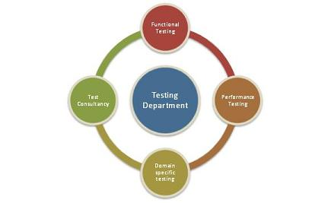
User acceptance testing (UAT) is conducted to validate the product against user expectations and requirements. This involves engaging end-users to evaluate the product's usability, accessibility, and overall user experience.
QA testers use a variety of testing techniques and tools to identify defects and bugs in the system. This may include manual testing, automated testing, performance testing, security testing, and usability testing, among others.
Throughout the testing process, QA testers document their findings, including any defects or issues discovered during testing. They work closely with development teams to prioritize and address these issues, ensuring that high-priority defects are resolved promptly.
Continuous improvement is a key aspect of QA testing, with testers regularly reviewing and refining testing processes and methodologies to enhance efficiency and effectiveness. This may involve implementing new tools, adopting best practices, and incorporating feedback from stakeholders to drive quality improvements.
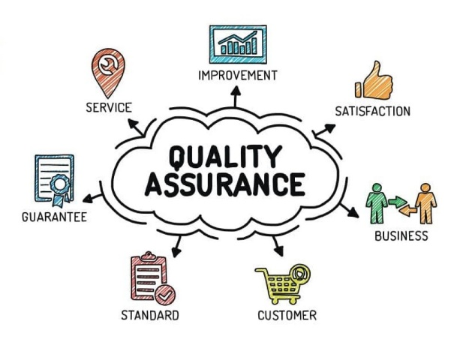
Grievance and Conflict Resolution Department:
The Grievance and Conflict Resolution department is responsible for managing disputes, grievances, and conflicts within the organization. This department serves as a neutral mediator, helping parties resolve issues in a fair and equitable manner.
One of the primary functions is to provide employees and stakeholders with a platform to express their concerns and grievances. This could involve setting up confidential reporting mechanisms, such as hotlines or online portals, where individuals can raise issues anonymously.
The department investigates complaints and conflicts thoroughly, gathering relevant information and evidence to understand the root causes of the problem. Depending on the nature of the issue, this may involve conducting interviews, reviewing documentation, or engaging in alternative dispute resolution methods like mediation or arbitration.
Once the investigation is complete, the department works towards finding a resolution that addresses the concerns of all parties involved. This could involve implementing corrective actions, revising policies or procedures, or providing training and support to prevent similar issues from arising in the future.
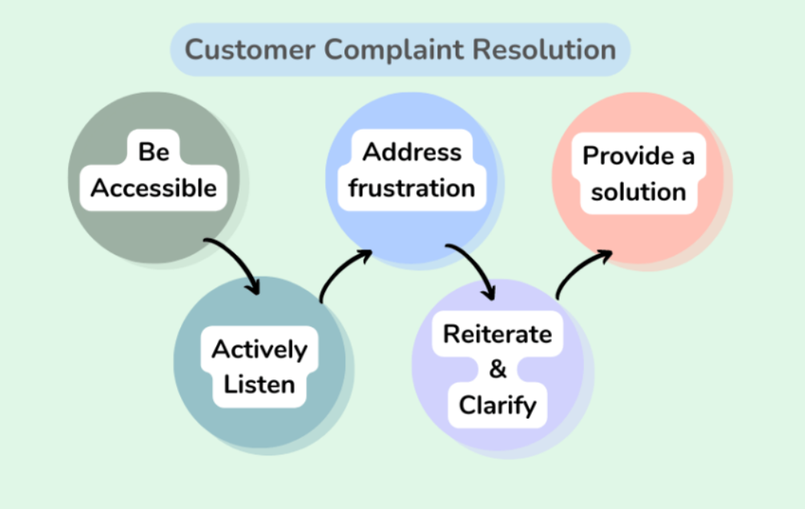
Figure 1.3.12 Customer Complaint Resolution
Additionally, the Grievance and Conflict Resolution department may play a role in promoting a positive organizational culture by fostering open communication, trust, and collaboration among employees. This includes promoting conflict resolution skills and providing resources for managing interpersonal conflicts effectively.

These departments play integral roles in ensuring the success and growth of EduPhoenix Solutions by effectively managing resources, delivering high-quality products and services, and delivers comprehensive educational solutions that empower learners, educators, and institutions to succeed in a rapidly evolving digital landscape.

  - Company Products/Applications
EduPhoenix Solutions prides itself on offering a diverse array of cutting-edge educational technology products and applications designed to cater to the evolving needs of educators and learners alike. Our commitment to innovation and excellence drives us to develop solutions that enhance teaching effectiveness, promote student engagement, and ultimately elevate the learning experience. Here's a detailed overview of our key products and applications:
- Learning Management System (LMS):
Our Learning Management System (LMS) serves as the cornerstone of our educational technology suite. This robust platform provides educators with the tools they need to create, deliver, and manage online courses and educational content seamlessly. With intuitive course creation features, comprehensive content management capabilities, and robust assessment tools, our LMS empowers educators to design dynamic and interactive learning experiences. Moreover, real-time analytics and reporting functionalities enable educators to monitor student progress and performance effectively.

- Virtual Classroom:
In today's digital age, our Virtual Classroom platform offers educators a versatile and immersive online learning environment. Equipped with video conferencing, screen sharing, interactive whiteboards, and chat functionality, this platform facilitates real-time collaboration and interaction between educators and students. Whether conducting live classes, webinars, or virtual workshops, educators can engage learners effectively and foster meaningful learning experiences. Seamless integration with our LMS ensures streamlined course delivery and administration.

- Interactive Content Authoring Tools:
Our suite of interactive content authoring tools empowers educators to create engaging and multimedia-rich learning materials with ease. Featuring user-friendly interfaces, customizable templates, and multimedia integration capabilities, these authoring tools enable educators to develop interactive presentations, quizzes, simulations, and games effortlessly. With built-in assessment and tracking features, educators can assess student comprehension and progress in real time, ensuring that learning objectives are met effectively.

- Professional Development Programs:
Recognizing the importance of continuous professional development, we offer a wide range of training courses and programs designed to enhance educators' skills and knowledge in educational technology and pedagogy. From digital literacy and blended learning to instructional design and technology integration, our professional development programs cover a diverse array of topics. Whether educators are looking to expand their expertise in specific areas or earn certifications in educational technology, our programs provide valuable opportunities for growth and advancement.
- Consultancy Services:
Our consultancy services cater to educational institutions seeking expert guidance and support in leveraging technology for teaching and learning. Our team of seasoned consultants collaborates closely with clients to assess their unique needs, develop tailored technology solutions, and provide ongoing training and support. From strategic planning and needs analysis to implementation and evaluation, our consultancy services empower institutions to maximize the impact of educational technology and achieve their educational goals effectively.

- IoT Projects:
Internet of Things (IoT) projects involve the integration of physical devices, sensors, and software applications to enable connectivity and data exchange. These projects often focus on leveraging IoT technologies to create smart systems, automate processes, and gather insights from real-world data. Eduphoenix Solutions offers a range of IoT projects aimed at providing hands-on learning experiences to students and professionals.
These projects typically cover areas such as:
Sensor Integration: Students learn to integrate various sensors such as temperature sensors, humidity sensors, motion sensors, and environmental sensors into IoT devices and systems.
Data Acquisition and Processing: Projects involve collecting data from sensors and processing it using microcontrollers or single-board computers like Arduino, Raspberry Pi, or ESP8266/ESP32.
Connectivity and Communication: Students explore different communication protocols such as Wi-Fi, Bluetooth, Zigbee, and LoRa to enable connectivity between IoT devices and networks.
IoT Applications: Projects may focus on developing IoT applications for smart homes, smart cities, industrial automation, healthcare monitoring, environmental monitoring, agriculture, and more.
Cloud Integration: Integration with cloud platforms such as AWS IoT, Google Cloud IoT, or Microsoft Azure IoT enables students to store, analyze, and visualize IoT data, as well as implement cloud-based services like remote monitoring and control.
Security and Privacy: Emphasis is placed on implementing security measures such as encryption, authentication, and access control to protect IoT systems from cyber threats and ensure data privacy.

- AI-ML Projects:
Artificial Intelligence (AI) and Machine Learning (ML) projects involve the development and application of algorithms and models to analyze data, make predictions, and automate tasks without explicit programming instructions. These projects harness the power of AI and ML techniques to solve complex problems, optimize processes, and extract insights from data. Eduphoenix Solutions offers a variety of AI-ML projects aimed at fostering understanding and proficiency in these transformative technologies.
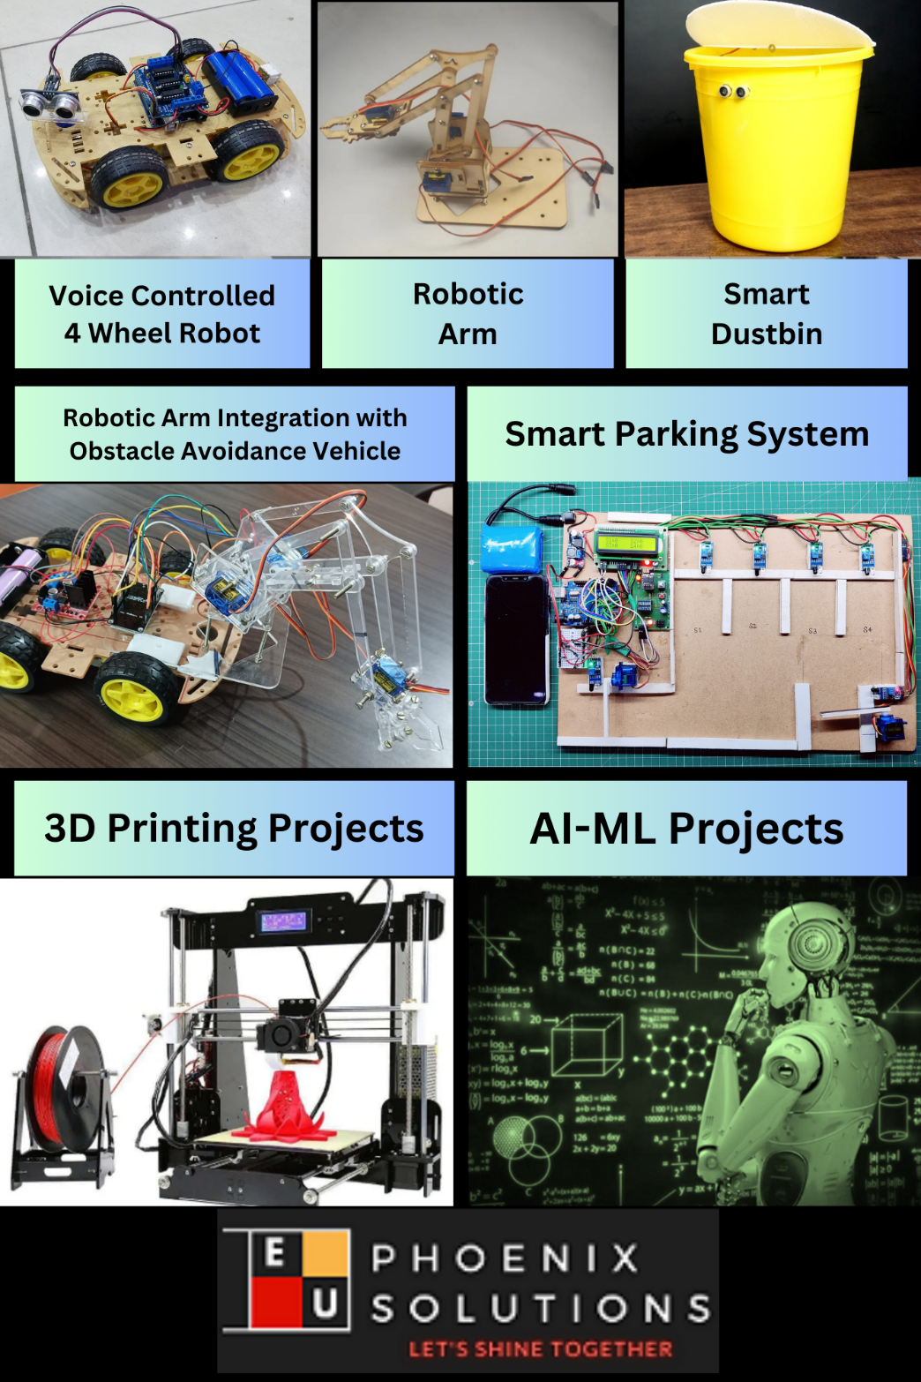

Figure 1.4.1 Company Products

Key components of AI-ML projects include:
Data Collection and Preparation: Projects begin with data collection from various sources such as sensors, databases, or web APIs. Data preprocessing techniques are then applied to clean, transform, and prepare the data for analysis.
Algorithm Selection and Model Development: Students explore different AI and ML algorithms such as regression, classification, clustering, neural networks, and deep learning to build predictive models and solve specific problems.
Model Training and Evaluation: The models are trained using abelled data, and their performance is evaluated using metrics such as accuracy, precision, recall, and F1-score. Hyperparameter tuning and cross-validation techniques are applied to optimize model performance.
Deployment and Integration: Once trained and evaluated, the models are deployed into production environments and integrated with existing systems or applications to deliver real-world value. This may involve deploying models on edge devices, cloud platforms, or IoT devices.

Overall, IoT and AI-ML projects offered by EduPhoenix Solutions provide participants with practical experience, critical thinking skills, and technical expertise in emerging technologies, preparing them for careers in the rapidly evolving fields of IoT and AI-ML.

CHAPTER 2
DOMAIN: FINANCE

2.1 Introduction
Introduction for Finance involves understanding the fundamental concepts and practices in the financial sector, encompassing areas such as investment, banking, and risk management. During an internship at EduPhoenix Solutions, you would have gained insights into the dynamic field of finance, learning about financial analysis, market trends, and investment strategies.
During your internship at EduPhoenix Solutions, you would have been introduced to various financial concepts and tools, such as financial modeling, valuation, and risk management. These skills are crucial for financial professionals to make informed decisions, evaluate investment opportunities, and manage financial risks.

Moreover, you would have had the opportunity to work on real-world projects, developing analytical and problem-solving skills that are highly valued in the finance industry. By collaborating with experienced professionals, you would have gained insights into the challenges and opportunities in the financial sector, preparing you for a successful career in finance.
Furthermore, your internship would have provided you with a solid foundation in financial regulations, compliance, and ethical considerations, ensuring that you are well-equipped to navigate the complex and dynamic financial landscape. You would have also developed strong communication and presentation skills, enabling you to effectively convey financial information to stakeholders and decision-makers.
In conclusion, your internship at EduPhoenix Solutions would have provided you with a comprehensive understanding of finance principles, practical experience in financial analysis, and exposure to real-world financial scenarios. This would have equipped you with the skills and knowledge necessary to pursue a successful career in finance, whether in investment banking, corporate finance, financial planning, or risk management.
Finance plays a crucial role in the global economy, influencing decision-making processes in businesses, governments, and individuals. It involves managing money, assets, and liabilities to achieve financial goals and optimize returns. Key aspects of finance include financial planning, budgeting, and forecasting to ensure financial stability and growth.
In the context of an internship at EduPhoenix Solutions, you may have been exposed to real-world financial scenarios, such as analyzing financial statements, evaluating investment opportunities, and understanding the impact of economic factors on financial markets. This hands-on experience would have provided you with practical skills and knowledge essential for a career in finance.
Overall, an internship in finance at EduPhoenix Solutions would have offered you a valuable opportunity to explore the intricacies of financial management, gain practical experience in financial analysis, and develop a solid foundation in finance principles, preparing you for a successful career in the finance industry.

2.2 Overview
During your internship at EduPhoenix Solutions, you would have gained a comprehensive understanding of finance principles and practices, including financial modeling, investment banking, and risk management. The internship program would have provided you with practical experience in financial analysis, allowing you to apply and further develop the skills you learned in the classroom.
The internship program at EduPhoenix Solutions is designed to offer a real-world setting to apply and further develop the skills you've learned in the classroom. You would have spent at least 50% of your time using and developing your professional skills, such as analysis and project management, and less than 25% on menial work like making photocopies or fetching lunch for your bosses and co-workers. The program would have allowed you to spend ample time doing challenging, rewarding work, and even with "grunt work," you would have earned points for capably and cheerfully doing whatever you were assigned.
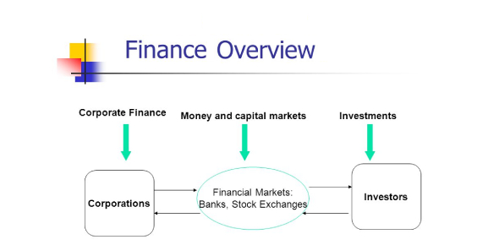

Furthermore, the internship program would have provided you with a competitive edge if you apply to that company for a full-time job. You would have gained experience to add to your resume, and the opportunity to develop real-time technical and managerial skills. Additionally, you would have learned about financial regulations, compliance, and ethical considerations, ensuring that you are well-equipped to navigate the complex and dynamic financial landscape.
During your internship at EduPhoenix Solutions, you would have gained exposure to various financial tools and software, such as Excel, Bloomberg, and MATLAB, which are commonly used in the finance industry. This would have provided you with hands-on experience in using these tools to analyze financial data, create financial models, and make informed investment decisions.
Moreover, you would have had the opportunity to work on real-world projects, such as analyzing financial statements, evaluating investment opportunities, and developing investment strategies. This would have allowed you to apply the financial concepts and skills you learned in the classroom to real-world scenarios, giving you a practical understanding of how finance works in the real world.
Additionally, you would have had the opportunity to work with experienced professionals in the finance industry, who would have served as mentors and provided guidance throughout your internship. This would have allowed you to learn from their expertise and gain insights into the challenges and opportunities in the financial sector. You would have also had the opportunity to network with professionals in the industry, building relationships that could be beneficial for your future career.

In conclusion, your internship at EduPhoenix Solutions would have provided you with a comprehensive understanding of finance principles, practical experience in financial analysis, and exposure to real-world financial scenarios. This would have equipped you with the skills and knowledge necessary to pursue a successful career in finance, whether in investment banking, corporate finance, financial planning, or risk management. The internship program would have also provided you with hands-on experience in using financial tools and software, real-world project experience, and mentorship from experienced professionals in the finance industry.

2.3 Financial Analysis
During your internship at EduPhoenix Solutions, you would have gained hands-on experience in financial analysis, a crucial aspect of finance. Financial analysis involves evaluating financial statements, budgets, and other financial data to make informed decisions about investments, business strategies, and financial health.
Moreover, you would have had the opportunity to work on real-world projects, such as analyzing financial statements, evaluating investment opportunities, and developing investment strategies. This would have allowed you to apply the financial concepts and skills you learned in the classroom to real-world scenarios, giving you a practical understanding of how financial analysis works in the real world.
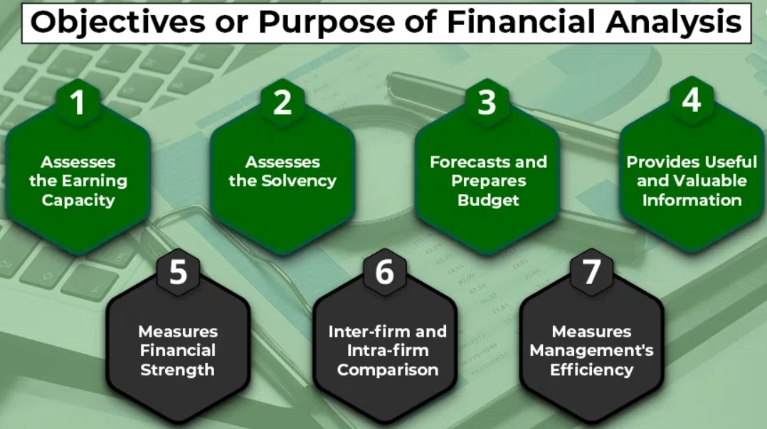

Additionally, you would have had the opportunity to work with experienced professionals in the finance industry, who would have served as mentors and provided guidance throughout your internship. This would have allowed you to learn from their expertise and gain insights into the challenges and opportunities in the financial sector. You would have also had the opportunity to network with professionals in the industry, building relationships that could be beneficial for your future career.
In the context of the finance internship program at EduPhoenix Solutions, you would have learned to analyze financial statements, evaluate investment opportunities, and develop investment strategies. You would have also gained exposure to financial modeling, valuation methodologies, and M&A analysis, which are essential skills for financial analysts.
Moreover, you would have developed a deep understanding of financial concepts, including budgeting, financial analysis, and investment appraisal, which are crucial for success in the finance industry. You would have also learned to formulate effective business strategies, analyze market trends, and identify growth opportunities, enhancing your strategic decision-making skills.
Additionally, you would have gained practical experience in analyzing stocks, industries, and market trends, enabling you to provide valuable insights for investment decisions. You would have also learned to develop comprehensive financial strategies for businesses, optimizing capital structures, and assessing investment opportunities.
In conclusion, your internship at EduPhoenix Solutions would have provided you with a comprehensive understanding of financial analysis, exposure to real-world financial scenarios, and hands-on experience in financial modeling, valuation methodologies, and investment strategies. This would have equipped you with the skills and knowledge necessary to pursue a successful career in finance, whether in investment banking, corporate finance, or financial analysis.

2.4 Planning, Budgeting & Forecasting
During your internship at EduPhoenix Solutions, you would have gained hands-on experience in planning, budgeting, and forecasting, which are essential components of financial management. These skills are crucial for financial professionals to make informed decisions, evaluate investment opportunities, and manage financial risks.
Planning involves setting financial goals, determining the resources required to achieve them, and developing strategies to allocate resources effectively. During your internship, you would have learned to create financial plans, set realistic financial goals, and monitor performance against targets. This would have enabled you to develop comprehensive financial strategies for businesses, optimize capital structures, and assess investment opportunities.
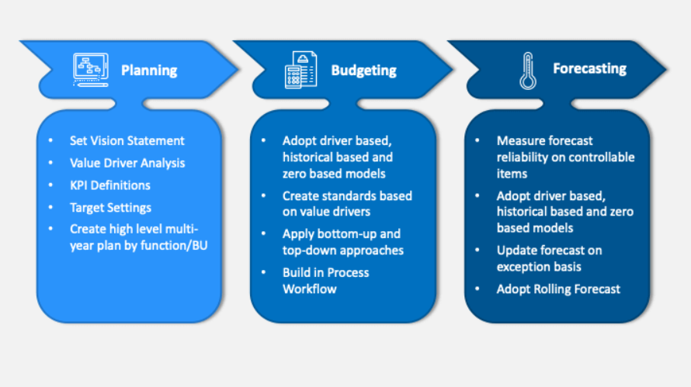
Budgeting is the process of creating a financial plan that outlines expected revenues and expenses over a specific period, helping organizations allocate resources effectively and achieve their financial goals. During your internship, you would have learned how to create and analyze budgets, identify key performance indicators, and assess variances to ensure financial stability and growth.
Forecasting involves predicting future financial outcomes based on historical data, market trends, and other relevant factors, enabling businesses to make informed decisions and plan for the future. During your internship, you would have gained expertise in using financial modeling tools and software to conduct forecasting analysis, enabling you to make accurate predictions and strategic decisions based on financial data.
Real-world applications are a critical aspect of the internship program at EduPhoenix Solutions. You would have applied your knowledge to real financial scenarios through live projects and case studies, gaining practical experience that sets you apart in the competitive finance industry. This hands-on experience would have enhanced your analytical abilities, decision-making skills, and strategic thinking, preparing you for a successful career in finance.
In conclusion, your internship at EduPhoenix Solutions would have provided you with a comprehensive understanding of planning, budgeting, and forecasting, practical experience in financial planning and analysis, and exposure to real-world financial scenarios. This experience would have equipped you with the skills and expertise needed to create effective financial plans, make accurate financial forecasts, and contribute to strategic decision-making processes in the finance industry.

2.5 Financial Reporting
During your internship at EduPhoenix Solutions, you would have gained valuable insights into financial reporting, a critical aspect of finance that involves the preparation and presentation of financial information to stakeholders, investors, and regulatory authorities. Financial reporting plays a crucial role in providing transparency and accountability in business operations, enabling informed decision-making and ensuring compliance with financial regulations.
The internship program at EduPhoenix Solutions would have provided you with hands-on experience in financial reporting, allowing you to develop practical skills in preparing financial statements, analyzing financial data, and communicating financial performance effectively. You would have learned how to create income statements, balance sheets, and cash flow statements, gaining expertise in interpreting financial information and assessing the financial health of an organization.
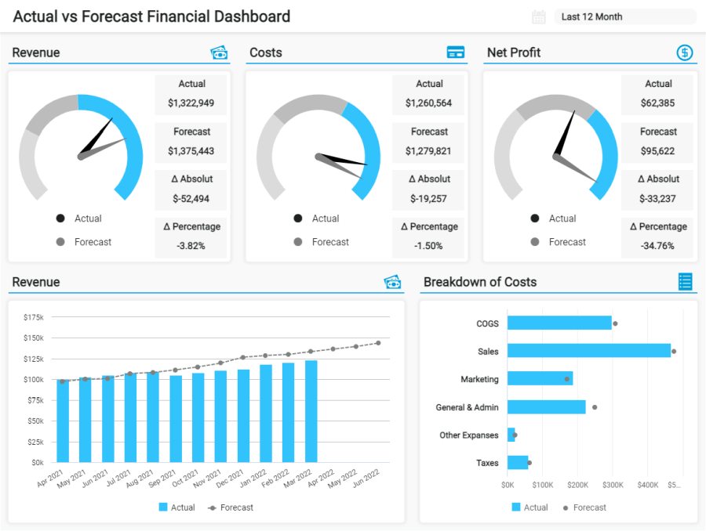
Figure 2.5 Financial Report Example
Moreover, during your internship, you would have worked on real-world projects that involved financial reporting tasks, such as analyzing financial statements, preparing financial reports, and conducting financial analysis. By collaborating with experienced professionals in the finance industry, you would have honed your financial reporting skills, learned best practices, and gained insights into industry standards and regulatory requirements. This hands-on experience would have enhanced your ability to prepare accurate and reliable financial reports that provide valuable insights for decision-making processes.
Furthermore, the internship program at EduPhoenix Solutions would have emphasized the importance of accuracy, transparency, and integrity in financial reporting. You would have learned the significance of adhering to accounting standards, regulatory guidelines, and ethical principles in financial reporting practices. Understanding the importance of maintaining the credibility and reliability of financial information would have been a key takeaway from your internship experience, equipping you with the skills and knowledge necessary to excel in financial reporting in the finance industry.
In conclusion, your internship at EduPhoenix Solutions would have provided you with a comprehensive understanding of financial reporting, practical experience in preparing financial statements and reports, and exposure to real-world financial reporting scenarios. This experience would have equipped you with the skills and expertise needed to create accurate financial reports, communicate financial information effectively, and contribute to transparent and reliable financial reporting practices in the finance industry.

2.5 Cash Flow Management
During your internship at EduPhoenix Solutions, you would have gained valuable insights into cash flow management, a critical aspect of finance that involves monitoring, analyzing, and optimizing the flow of cash in and out of an organization. Cash flow management is essential for ensuring liquidity, meeting financial obligations, and supporting business operations effectively.
The internship program at EduPhoenix Solutions would have provided you with hands-on experience in cash flow management, allowing you to develop practical skills in monitoring cash inflows and outflows, forecasting cash needs, and implementing strategies to maintain optimal cash flow levels. You would have learned how to create cash flow statements, analyze cash flow patterns, and identify opportunities to improve cash flow efficiency.
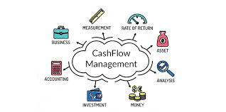
Moreover, during your internship, you would have worked on real-world projects that involved cash flow management tasks, such as preparing cash flow projections, analyzing working capital requirements, and optimizing cash flow cycles. By collaborating with experienced professionals in the finance industry, you would have honed your cash flow management skills, learned best practices, and gained insights into industry standards and strategies for effective cash flow management.
Furthermore, the internship program at EduPhoenix Solutions would have emphasized the importance of cash flow management in financial planning and analysis. You would have learned how to develop cash flow forecasts, assess liquidity risks, and implement cash flow improvement initiatives to enhance financial stability and support business growth. Understanding the significance of cash flow management in driving financial decisions and ensuring operational efficiency would have been a key takeaway from your internship experience, equipping you with the skills and knowledge necessary to excel in cash flow management in the finance industry.
In conclusion, your internship at EduPhoenix Solutions would have provided you with a comprehensive understanding of cash flow management, practical experience in monitoring and analyzing cash flows, and exposure to real-world cash flow management scenarios. This experience would have equipped you with the skills and expertise needed to optimize cash flow, manage liquidity effectively, and contribute to strategic decision-making processes in the finance industry.

2.6 Investment Analysis
During your internship at EduPhoenix Solutions, you would have gained hands-on experience in investment analysis, a critical aspect of finance that involves evaluating investment opportunities, assessing risks, and making informed decisions. Investment analysis is essential for financial professionals to optimize investment portfolios, manage financial risks, and maximize returns.
The internship program at EduPhoenix Solutions would have provided you with hands-on experience in various investment analysis techniques, including financial modeling, valuation methodologies, and M&A analysis. You would have learned to analyze historical data, forecast future performance, and assess investment viability, enabling you to make informed investment decisions.

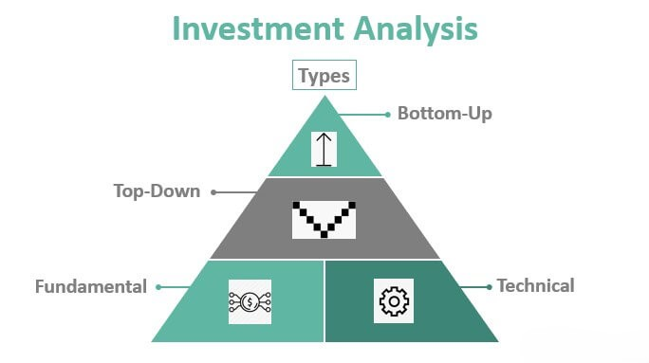

Moreover, during your internship, you would have worked on real-world projects that involved investment analysis tasks, such as analyzing financial statements, preparing financial reports, and conducting financial analysis. By collaborating with experienced professionals in the finance industry, you would have honed your investment analysis skills, learned best practices, and gained insights into industry standards and strategies for effective investment analysis.
Furthermore, the internship program at EduPhoenix Solutions would have emphasized the importance of risk management in investment analysis. You would have learned how to assess investment risks, develop risk mitigation strategies, and optimize investment portfolios to achieve a balance between risk and return. Understanding the significance of risk management in investment analysis would have been a key takeaway from your internship experience, equipping you with the skills and knowledge necessary to excel in investment analysis in the finance industry.
In conclusion, your internship at EduPhoenix Solutions would have provided you with a comprehensive understanding of investment analysis, practical experience in analyzing financial data, and exposure to real-world investment analysis scenarios. This experience would have equipped you with the skills and expertise needed to optimize investment portfolios, manage financial risks, and contribute to strategic decision-making processes in the finance industry.

CHAPTER 3
INTERNSHIP TASK/DAILY-LOGS

The internship experience at EduPhoenix in Financial Modeling and Investment Banking was an extensive learning journey that blended theoretical knowledge with practical application. Throughout the internship, participants engaged in various sessions that systematically built their expertise in financial modeling, investment analysis, and corporate finance. Each session provided a stepping stone towards mastering complex financial concepts, models, and real-world applications. Below is a detailed account of the tasks, activities, and key learning outcomes for each session, encapsulating the growth and development over the course of the internship.
Session 1: Introduction to Financial Modeling
The first session laid the foundation by introducing interns to the principles of financial modeling. Financial models are essential tools used by analysts, investors, and financial professionals to forecast a company’s financial performance, make investment decisions, and assess risks. The session outlined the different types of financial models, including Discounted Cash Flow (DCF) models, sensitivity analysis, and forecasting models. The emphasis was on understanding how financial models drive decision-making and valuation in businesses.
Daily Task:
- Research and Exploration: Interns were asked to research various financial models used across industries and compile a report on the types of models, their structure, and their practical applications.
- Basic Model Construction: A simple financial model was created using historical financial data. Interns applied revenue growth assumptions, cost projections, and other variables to build out the model.
- Industry Analysis: Interns studied how financial models influence industries such as technology, retail, and manufacturing by examining case studies where financial decisions were guided by model forecasts.
Learning Outcome: By the end of this session, interns had a strong understanding of the role of financial modeling in corporate finance and investment banking. They also gained hands-on experience in creating basic models and analyzing industry case studies.
Session 2: Building Financial Statements
Understanding and building financial statements are critical to any financial model. This session covered the income statement, balance sheet, and cash flow statement in detail. Interns were introduced to the structure of each statement, the purpose they serve, and how they interconnect in financial analysis. They learned to extract financial data, organize it, and use it to build financial models.
Daily Task:
- Creation of Financial Statements: Interns were given financial data for a hypothetical company and tasked with creating detailed financial statements. The focus was on accuracy and the ability to connect all three statements.
- Linking Statements: Interns learned how the income statement feeds into the balance sheet through retained earnings, and how the cash flow statement reconciles net income with actual cash movements.
- Ratio Analysis and Financial Health Check: Interns performed a ratio analysis, assessing liquidity, profitability, solvency, and efficiency ratios. This gave them a better understanding of how companies evaluate their financial health.
Learning Outcome: Interns developed an ability to construct complete financial statements and grasped the interconnected nature of these documents. They also gained proficiency in interpreting financial data and using it for ratio analysis.
Session 3: Valuation Techniques
Valuation is the cornerstone of financial modeling, particularly in investment banking, mergers and acquisitions, and private equity. In this session, interns learned about different valuation techniques, including Discounted Cash Flow (DCF) analysis, Comparable Company Analysis (CCA), and Precedent Transaction Analysis (PTA). Each valuation method was broken down to showcase its strengths, limitations, and specific use cases.
Daily Task:
- Building a DCF Model: Interns constructed a detailed DCF model to estimate the intrinsic value of a company. They calculated future free cash flows and discounted them to present value using the company’s Weighted Average Cost of Capital (WACC).
- Comparable Company Valuation: Interns performed a CCA by identifying peer companies and analyzing their financial metrics, such as revenue multiples, P/E ratios, and EV/EBITDA.
- Sensitivity and Scenario Testing: Using their DCF models, interns applied sensitivity analysis to test the impact of different assumptions on the company’s valuation, such as varying discount rates or growth assumptions.
Learning Outcome: Interns learned how to use multiple valuation methods to estimate the value of companies, providing them with tools to make informed financial decisions. They also gained experience in scenario testing and understanding how small changes in assumptions can significantly impact valuation outcomes.
Session 4: Mergers and Acquisitions (M&A) Fundamentals
This session introduced interns to the world of mergers and acquisitions (M&A), a vital component of corporate finance. Interns learned about the lifecycle of an M&A deal, from deal origination and negotiation to due diligence and post-merger integration. The session also emphasized the strategic rationale behind M&A transactions, such as achieving synergies, market expansion, and operational efficiency.
Daily Task:
- M&A Deal Structuring: Interns were asked to structure a mock M&A deal between two hypothetical companies. They considered the financing mix (debt vs. equity), deal terms, and integration strategies.
- Synergy Identification and Valuation: Interns were tasked with identifying potential synergies in their mock deal and modeling their impact on the combined company’s valuation.
- Real-World Case Study Analysis: Interns analyzed high-profile M&A transactions, studying the rationale behind these deals and whether they succeeded in creating shareholder value.
Learning Outcome: Interns developed a deep understanding of the M&A process, including deal structuring, synergy identification, and the role of financial modeling in evaluating M&A opportunities. They also gained insight into the strategic considerations that drive M&A decisions.
Session 5: Leveraged Buyouts (LBO) Modeling
In this session, interns learned about leveraged buyouts (LBOs), where companies are acquired primarily using debt. The session covered the key components of an LBO transaction, including debt structuring, cash flow generation, and equity returns. Interns were introduced to the IRR (Internal Rate of Return) and the importance of exit strategies in LBO deals.
Daily Task:
- Building an LBO Model: Interns were tasked with building a basic LBO model. They projected cash flows, interest expenses, and debt repayment schedules to calculate the equity returns for a hypothetical private equity firm.
- Exit Strategy Scenarios: Interns modeled multiple exit strategies, such as selling the company after five years or taking it public, and calculated the IRR for each scenario.
- Risk and Return Analysis: Interns assessed the risks associated with high leverage, including market downturns and operational challenges, and how these risks impact equity returns.
Learning Outcome: Interns gained practical experience in building LBO models and understanding the intricacies of debt financing in private equity. They also learned how to assess the risks and returns associated with LBO transactions.
Session 6: Financial Modeling for Project Finance
Project finance involves long-term financing for infrastructure and industrial projects, where repayment is based on the project's cash flows rather than the company’s balance sheet. This session covered the unique aspects of project finance, including risk allocation, financial structuring, and the role of Special Purpose Vehicles (SPVs).
Daily Task:
- Project Cash Flow Modeling: Interns were asked to build a financial model for a large-scale project, projecting revenues, operating costs, capital expenditures, and financing needs over the project’s lifecycle.
- Risk Allocation: Interns identified key risks in the project, such as construction delays, regulatory hurdles, and market demand fluctuations, and modeled their potential financial impact.
- Financial Metrics Calculation: Interns calculated key project finance metrics, such as the debt service coverage ratio (DSCR) and the internal rate of return (IRR), to assess the project’s financial viability.
Learning Outcome: Interns developed the ability to model complex projects and assess the risks and returns associated with project finance. They also learned about the specific challenges and opportunities in financing large infrastructure projects.
Session 7: Investment Banking Overview
The investment banking industry is vast and multifaceted, offering services such as M&A advisory, capital raising, and underwriting. This session provided a comprehensive overview of the different divisions within an investment bank and the services they offer to corporate clients. Interns were introduced to the role of investment banks in facilitating major financial transactions, such as Initial Public Offerings (IPOs) and bond issuances.
Daily Task:
- Departmental Research: Interns researched the various departments within an investment bank, such as M&A advisory, debt capital markets, and equity research, and provided summaries of their roles and responsibilities.
- Client Pitch Simulation: Interns worked on a mock client pitch for an IPO, preparing a presentation that outlined the company’s financials, valuation, and proposed offering structure.
- Case Study Review: Interns reviewed a real-world case study of an IPO or bond issuance, analyzing the steps taken by the investment bank to bring the deal to market.
Learning Outcome: Interns gained a comprehensive understanding of the role of investment banks in capital markets and corporate transactions. They also developed communication and presentation skills through the client pitch simulation.

Session 8: Regulatory and Compliance Aspects
The financial industry is highly regulated to ensure transparency, fairness, and ethical conduct. This session introduced interns to key regulatory frameworks, such as Sarbanes-Oxley, Dodd-Frank, and Basel III. Interns learned about the compliance requirements for financial institutions and the consequences of non-compliance.
Daily Task:
- Regulatory Research: Interns researched key regulatory bodies, such as the Securities and Exchange Commission (SEC), and the regulations that impact financial modeling and corporate finance.
- Compliance Risk Assessment: Interns were given a hypothetical transaction and tasked with identifying potential compliance risks, such as insider trading or conflicts of interest, and proposing mitigation strategies.
- Ethical Dilemmas in Finance: Interns discussed real-world ethical dilemmas faced by financial professionals and how regulatory frameworks help address these challenges.
Learning Outcome: Interns developed a strong understanding of the regulatory environment that governs financial markets and corporate transactions. They also gained insight into the ethical considerations and compliance challenges faced by financial professionals, emphasizing the importance of adhering to regulations to maintain transparency and trust in the industry.
Session 9: Mock Deal Simulation
This hands-on session was one of the most intensive parts of the internship, as interns participated in a mock deal simulation that integrated all the concepts they had learned. The simulation mimicked a real-life financial transaction, allowing interns to apply their skills in financial modeling, valuation, M&A, and regulatory compliance.
Daily Task:
- Deal Structuring: Interns were divided into teams and assigned roles, such as buyer, seller, or advisor. They were tasked with structuring a hypothetical deal, including negotiations on pricing, terms, and financing options.
- Valuation and Due Diligence: Each team had to perform due diligence, build financial models, and conduct valuations to assess the potential deal. This involved extensive analysis of financial statements, market conditions, and strategic fit.
- Presentation and Negotiation: Teams presented their deal proposals to a panel of evaluators, simulating a boardroom environment. They also engaged in negotiations with opposing teams to finalize deal terms, including price adjustments based on valuations and synergy opportunities.

Learning Outcome: Interns experienced the high-pressure environment of deal-making, applying their financial knowledge to real-world scenarios. This simulation honed their negotiation, teamwork, and problem-solving skills, providing a comprehensive understanding of how financial transactions are executed from start to finish.
Session 10: Analysis & Transactions
The final session focused on the post-deal analysis and ongoing transaction management. Interns were introduced to the importance of monitoring deal performance, ensuring that projected synergies and financial outcomes are realized after the transaction closes. They also learned about post-merger integration challenges, the importance of continuous financial monitoring, and performance measurement.
Daily Task:
- Post-Deal Financial Monitoring: Interns were tasked with building a model to track the financial performance of a recently completed mock deal. This included analyzing cash flows, cost savings, and revenue growth to measure whether the expected synergies were being achieved.
- Integration Challenges: Interns discussed the common post-merger integration issues, such as cultural clashes, operational inefficiencies, and unexpected financial impacts, and brainstormed solutions to mitigate these risks.
- Final Transaction Review: Each intern wrote a final report summarizing their role in the mock deal simulation, the financial outcomes, lessons learned, and recommendations for future transactions.
Learning Outcome: Interns gained a deep understanding of post-deal financial analysis and the ongoing importance of monitoring transactions. They learned that deal success is not guaranteed at closing, and continuous evaluation is key to ensuring long-term financial gains.

Conclusion
The internship program provided a well-rounded, immersive experience in financial modeling, investment banking, and corporate finance. Through structured sessions and hands-on tasks, interns developed both technical skills and practical knowledge in various aspects of finance. From building financial models and conducting valuations to structuring deals and ensuring compliance, the program gave interns an invaluable insight into the workings of the financial world.
By the end of the internship, interns were equipped with a strong foundation in financial modeling, a thorough understanding of corporate transactions, and a readiness to face real-world challenges in the financial industry. This experience not only enhanced their technical capabilities but also strengthened their critical thinking, problem-solving, and communication skills, preparing them for future roles in finance and investment banking.
CHAPTER 4
PROJECT
1. Project Overview
The main focus of this project was to perform a comprehensive financial analysis and valuation of a mid-sized manufacturing company. The goal was to determine the financial health, evaluate the company's market value, and propose recommendations for future growth and expansion strategies. The project applied the concepts learned during the internship sessions on financial modeling, building financial statements, valuation techniques, mergers and acquisitions, leveraged buyouts, and project finance. The analysis provided practical exposure to real-world financial scenarios, enabling a better understanding of complex financial principles and their application in business decision-making.
This project also aimed to offer actionable insights by leveraging data from the company’s historical financial statements and external market data to support growth initiatives, potential mergers, and acquisition opportunities. Additionally, the project provided an opportunity to understand how financial statements are interconnected and how they affect business performance.
2. Objectives of the Project
The project aimed to achieve the following objectives:
- Financial Statement Analysis: To evaluate the company's financial health by analyzing its profitability, liquidity, solvency, and efficiency.
- Company Valuation: To assess the intrinsic value of the company using valuation techniques like Discounted Cash Flow (DCF) and Comparable Company Analysis (CCA).
- Growth Potential: To identify key growth opportunities and risks based on financial data and market conditions, including possible mergers and acquisitions (M&A).
- Strategic Recommendations: To provide recommendations for improving operational efficiency, financial stability, and strategies for raising capital for expansion.
3. Methodology
The financial analysis and valuation of the company were carried out through a structured methodology. This involved detailed research, data collection, and the application of financial modeling techniques. The key steps in the methodology were as follows:
- Collection of Financial Data:
  - Historical financial statements of the company, including income statements, balance sheets, and cash flow statements for the past five years, were collected.
  - Market data and financial performance of competitors were also gathered for comparison and benchmarking purposes.
- Financial Statement Analysis:
  - Key financial ratios were calculated to assess the company's performance in areas such as profitability (e.g., gross margin, return on equity), liquidity (e.g., current ratio, quick ratio), solvency (e.g., debt-to-equity ratio), and efficiency (e.g., asset turnover ratio).
  - Trend analysis was conducted to understand how the company’s financial performance had evolved over time and to identify potential areas for improvement.
- Building Financial Models:
  - A detailed financial model was built to forecast future performance based on key assumptions such as revenue growth, operating costs, capital expenditure, and working capital.
  - Different scenarios were tested to assess the impact of changes in market conditions on the company’s financial performance.
- Valuation Techniques:
  - Discounted Cash Flow (DCF) Analysis: The company’s future free cash flows were forecasted and discounted to their present value using the Weighted Average Cost of Capital (WACC) as the discount rate. This helped in determining the company’s intrinsic value.
  - Comparable Company Analysis (CCA): A comparative analysis was conducted using market multiples (e.g., P/E ratio, EV/EBITDA) of similar companies in the manufacturing sector to estimate the company's market value.
- Risk Analysis and Sensitivity Testing:
  - A sensitivity analysis was performed to test how different variables, such as discount rates, revenue growth, and operating margins, would affect the valuation results.
  - Key risks were identified, including market volatility, regulatory changes, and supply chain risks, which could impact the company’s financial health and future growth.
4. Key Findings
- Financial Performance:
  - The company demonstrated stable growth in revenue, with an average annual growth rate of 8% over the past five years. Profit margins were also healthy, with the gross margin averaging around 30% and the net profit margin at 12%.
  - The company’s liquidity position was strong, with a current ratio of 2.5, indicating its ability to meet short-term liabilities. The quick ratio was 1.8, further suggesting sufficient liquidity to cover immediate obligations.
  - Solvency ratios, such as a debt-to-equity ratio of 0.6, revealed that the company maintained a balanced capital structure, relying on a mix of equity and debt without overleveraging itself.
  - Operating efficiency was satisfactory, with the asset turnover ratio consistently above 1.2, showing the company’s ability to efficiently utilize its assets to generate revenue.
- Valuation Results:
  - The DCF analysis yielded an intrinsic value of approximately $1.2 billion, based on a WACC of 7.5% and a terminal growth rate of 3%. This value suggests that the company is currently undervalued in the market.
  - The Comparable Company Analysis (CCA) indicated a market value of $1.15 billion, using the average EV/EBITDA and P/E ratios of peer companies in the same industry.
  - The alignment of the DCF and CCA results provided confidence in the accuracy of the valuation, highlighting that the company offers significant growth potential.
- Risk Assessment:
  - The sensitivity analysis revealed that the company’s valuation is highly sensitive to changes in revenue growth and WACC. A 1% decrease in WACC would increase the company’s intrinsic value by approximately $100 million, while a 1% drop in revenue growth would reduce the value by around $80 million.
  - The primary risks identified included supply chain disruptions, raw material price fluctuations, and potential regulatory changes, especially with respect to environmental regulations affecting the manufacturing sector.
- Growth Opportunities:
  - The company has significant opportunities for growth, especially in expanding its operations into international markets. By leveraging its strong financial position, the company could consider acquisitions to accelerate its global presence.
  - Additionally, technological advancements in the manufacturing process could help the company improve operational efficiency, reduce costs, and increase profitability.
5. Strategic Recommendations
Based on the analysis, several key strategic recommendations were made to support the company’s continued growth:
- Pursue International Expansion:
  - The company should invest in expanding its operations into high-growth emerging markets, where demand for manufacturing products is expected to increase significantly over the coming years.
- Strengthen Supply Chain Resilience:
  - To mitigate supply chain risks, the company should diversify its supplier base and establish long-term contracts with reliable suppliers to ensure a steady supply of raw materials at competitive prices.
- Optimize Capital Structure:
  - With a relatively low debt-to-equity ratio, the company has the capacity to raise additional debt at favorable interest rates. This could be used to finance expansion projects or strategic acquisitions without putting too much strain on the company’s balance sheet.
- Invest in Technology and Automation:
  - Investing in advanced manufacturing technologies and automation could help the company reduce production costs, improve efficiency, and maintain competitive pricing in the global market.
- Enhance Risk Management Strategies:
  - The company should actively monitor macroeconomic trends and implement risk mitigation strategies, such as hedging against commodity price fluctuations and foreign exchange risks.
6. Conclusion
The financial analysis and valuation of the company provided a detailed understanding of its current financial health and future growth potential. The company demonstrated strong profitability, liquidity, and solvency, with an intrinsic value that suggests it is undervalued in the market.
By pursuing the recommended strategies, the company can enhance its operational efficiency, strengthen its supply chain, and expand into new markets, thereby unlocking further growth and value for its shareholders. The project provided valuable insights into the practical application of financial modeling and valuation techniques, highlighting the importance of financial analysis in supporting strategic business decisions.
This project has reinforced key financial concepts and provided hands-on experience in financial analysis, valuation, and strategic planning, which will be instrumental in future roles within corporate finance, investment banking, and consulting.

CHAPTER 5
CAREER OPPORTUNITIES

As an intern at EduPhoenix Solutions, you'll gain valuable experience and skills that open up numerous career opportunities in the dynamic field of Finance. Here's a detailed overview of some of the career paths you can pursue:
1. Financial Analyst: As a financial analyst, you'll dive deep into financial data to provide insights and recommendations that drive strategic decision-making within organizations. Your responsibilities may include financial modeling, forecasting, variance analysis, and performance reporting. This role is crucial for understanding the financial health of a company and identifying areas for improvement.

2. Investment Banking Analyst: In this role, you'll work closely with senior bankers to execute financial transactions such as mergers, acquisitions, and public offerings. You'll conduct financial valuation, perform due diligence, and assist in the preparation of offering documents. This fast-paced environment offers exposure to high-profile deals and requires strong analytical and communication skills.

3. Risk Analyst: Risk analysts assess the potential risks faced by a company and develop strategies to mitigate them. This could involve analyzing market risk, credit risk, operational risk, or regulatory compliance risk. By identifying and managing risks effectively, you'll help safeguard the company's financial stability and protect its reputation.

4. Corporate Finance Associate: As a corporate finance associate, you'll support financial planning, budgeting, and forecasting activities within a company. You'll collaborate with various departments to develop financial projections, evaluate investment opportunities, and allocate resources efficiently. This role requires strong analytical skills and the ability to communicate complex financial concepts to non-financial stakeholders.

5. Portfolio Manager: Portfolio managers oversee investment portfolios on behalf of individuals, institutions, or funds. You'll develop investment strategies, allocate assets across different classes, and monitor portfolio performance. By making informed investment decisions, you'll aim to achieve financial objectives such as capital preservation, income generation, or capital appreciation.

6. Credit Analyst: Credit analysts assess the creditworthiness of individuals or companies seeking financing. You'll analyze financial statements, credit reports, and other relevant information to evaluate repayment capacity and default risk. This role is critical for mitigating credit losses and ensuring responsible lending practices.

7. Financial Consultant: Financial consultants provide personalized financial advice to individuals or businesses based on their goals and circumstances. You'll conduct comprehensive financial planning, recommend investment strategies, and assist clients in achieving their financial objectives. This role requires strong interpersonal skills and the ability to build trust with clients.

8. Treasury Analyst: Treasury analysts manage cash flow, liquidity, and financial risk for a company. You'll monitor cash balances, forecast cash needs, and execute financial transactions such as investments, borrowings, and foreign exchange trades. By optimizing liquidity and managing financial risks, you'll help ensure the company's financial stability and flexibility.

9. Financial Controller: Financial controllers oversee financial reporting, compliance, and internal controls within an organization. You'll supervise accounting operations, prepare financial statements, and ensure compliance with accounting standards and regulations. This role requires strong leadership skills and a solid understanding of financial principles and regulations.

10. Investment Research Analyst: Investment research analysts conduct research and analysis on financial markets, industries, and specific investment opportunities. You'll analyze economic trends, company financials, and industry dynamics to identify investment opportunities and risks. Your insights and recommendations guide investment decisions and portfolio allocations.

11. Asset Manager: Asset managers manage and optimize the performance of investment assets such as stocks, bonds, and real estate. You'll develop investment strategies, conduct research, and monitor asset allocations to maximize returns while managing risk. This role requires a deep understanding of financial markets and investment products.

12. Financial Planner: Financial planners help individuals or families create comprehensive financial plans to achieve their long-term goals. You'll assess clients' financial situations, identify their objectives, and develop personalized strategies for retirement planning, education funding, estate planning, and risk management. This role combines financial expertise with empathy and communication skills.

13. Compliance Officer: Compliance officers ensure that financial activities comply with relevant laws, regulations, and industry standards. You'll develop compliance policies and procedures, conduct internal audits, and provide training to employees on regulatory requirements. By promoting a culture of compliance, you'll help protect the company from legal and reputational risks.

14. Quantitative Analyst: Quantitative analysts, or "quants," use mathematical and statistical models to analyze financial markets and develop trading strategies. You'll apply advanced quantitative techniques to price securities, assess risk exposures, and optimize trading algorithms. This role requires strong quantitative skills, programming proficiency, and a deep understanding of financial markets.

15. Financial Auditor: Financial auditors examine financial records and statements to ensure accuracy, completeness, and compliance with accounting standards and regulations. You'll assess internal controls, perform substantive testing, and issue audit reports with findings and recommendations. This role plays a critical role in promoting transparency and accountability in financial reporting.

Each of these career opportunities offers unique challenges and opportunities for growth within the field of finance. Whether you're interested in analysis, management, compliance, or client advisory services, there's a diverse range of roles to explore based on your skills, interests, and career aspirations.

CHAPTER 6
FUTURE TRENDS
As an intern at EduPhoenix Solutions, it's essential to stay informed about the latest trends and advancements shaping the future of Finance. Here are some key trends to watch out for:
1. Blockchain Technology: The adoption of blockchain technology is expected to revolutionize various aspects of finance, including transactions, contracts, and identity verification. Blockchain offers secure, transparent, and tamper-proof record-keeping, which can streamline processes and reduce costs for financial institutions.

2. Digital Currencies and Central Bank Digital Currencies (CBDCs): The rise of digital currencies such as Bitcoin and Ethereum is reshaping the landscape of finance. Central banks are exploring the issuance of CBDCs, which could provide a secure and efficient alternative to traditional fiat currencies. This trend has implications for payment systems, monetary policy, and financial inclusion.

3. Artificial Intelligence (AI) and Machine Learning: AI and machine learning technologies are being increasingly integrated into financial services, enabling automation, predictive analytics, and personalized customer experiences. AI-powered chatbots, robo-advisors, and fraud detection systems are examples of applications transforming the finance industry.

4. Big Data Analytics: The proliferation of data in finance presents both opportunities and challenges. Big data analytics allows financial institutions to extract actionable insights from large volumes of structured and unstructured data, leading to improved risk management, customer segmentation, and decision-making.

5. Fintech Innovation: The fintech sector continues to innovate and disrupt traditional financial services, offering solutions such as peer-to-peer lending, digital wallets, and crowdfunding platforms. Fintech startups are challenging incumbents by leveraging technology to provide faster, cheaper, and more accessible financial products and services.

6. Regulatory Technology (Regtech): As regulatory requirements become increasingly complex, financial institutions are turning to regtech solutions to automate compliance processes, monitor regulatory changes, and ensure adherence to regulatory standards. Regtech tools help reduce compliance costs, minimize risks, and enhance regulatory reporting capabilities.

7. Sustainable Finance and ESG Investing: There is growing awareness of environmental, social, and governance (ESG) factors among investors and regulators. Sustainable finance initiatives promote responsible investing, green financing, and corporate sustainability reporting. ESG criteria are increasingly integrated into investment decisions and risk assessments.

8. Open Banking: Open banking initiatives enable customers to securely share their financial data with third-party providers through APIs (Application Programming Interfaces). This facilitates innovation, competition, and collaboration in financial services, leading to new products and services tailored to customer needs.

9. Cybersecurity and Data Privacy: With the increasing digitization of financial services, cybersecurity threats are a growing concern for financial institutions and their customers. Investments in cybersecurity measures, such as encryption, authentication, and threat intelligence, are essential to safeguarding sensitive financial data and maintaining trust.

10. Remote Work and Digital Transformation: The COVID-19 pandemic has accelerated the adoption of remote work and digital transformation in the finance industry. Cloud computing, virtual collaboration tools, and digital platforms are enabling financial institutions to operate more flexibly, efficiently, and securely in a distributed work environment.

11. Alternative Finance and Crowdfunding: Alternative finance channels, such as crowdfunding, peer-to-peer lending, and alternative investment platforms, are gaining traction as viable alternatives to traditional banking and capital markets. These platforms democratize access to capital and investment opportunities, empowering individuals and small businesses.

12. Quantum Computing: Quantum computing holds the potential to revolutionize finance by solving complex optimization problems, simulating financial models, and enhancing cybersecurity measures. Although still in the early stages of development, quantum computing could offer significant advantages in areas such as portfolio optimization, risk management, and algorithmic trading.

13. Robotic Process Automation (RPA): RPA technology automates repetitive tasks and processes in finance, such as data entry, reconciliation, and reporting. By reducing manual effort and errors, RPA improves efficiency, accuracy, and scalability, freeing up employees to focus on higher-value activities.

14. Decentralized Finance (DeFi): DeFi refers to financial services built on blockchain technology that operate without intermediaries or centralized control. DeFi platforms offer a wide range of services, including lending, borrowing, trading, and asset management, with increased transparency, security, and accessibility compared to traditional finance.

15. Personalized Financial Services: Advances in data analytics, AI, and machine learning enable financial institutions to offer personalized products and services tailored to individual customer needs, preferences, and behaviors. From personalized investment portfolios to customized insurance plans, personalized financial services enhance customer satisfaction and loyalty.

These future trends in finance present exciting opportunities and challenges for professionals in the industry. By staying abreast of these developments and embracing innovation, financial institutions can adapt to evolving market dynamics and deliver value to their customers in a rapidly changing digital landscape.

CHAPTER 7
CONCLUSION

One of the key takeaways from my internship is the increasing importance of technology and innovation in shaping the future of finance. From blockchain and artificial intelligence to fintech and digital transformation, technology is driving unprecedented changes in how financial services are delivered, consumed, and regulated. As financial institutions adapt to these technological advancements, they must also navigate complex regulatory landscapes, cybersecurity risks, and evolving customer expectations.
Furthermore, the rise of sustainable finance and ESG investing underscores the growing recognition of environmental, social, and governance factors in investment decision-making. As investors demand greater transparency, accountability, and sustainability from companies, finance professionals play a pivotal role in integrating ESG criteria into investment strategies and risk management practices.
The COVID-19 pandemic has accelerated trends such as remote work, digitalization, and resilience planning, highlighting the importance of agility, adaptability, and contingency planning in finance. As financial institutions strive to enhance operational efficiency, mitigate risks, and meet evolving customer needs in a post-pandemic world, they must embrace innovation, collaboration, and continuous learning.
Looking ahead, the future of finance holds both challenges and opportunities for professionals seeking to make a meaningful impact in the industry. Whether it's harnessing the power of emerging technologies, addressing sustainability challenges, or navigating regulatory complexities, finance professionals must remain agile, forward-thinking, and customer-centric in their approach.
In conclusion, my internship at EduPhoenix Solutions has equipped me with the skills, knowledge, and mindset to thrive in the dynamic and ever-evolving field of finance. I am excited to leverage my experiences and insights to contribute to positive change and innovation in finance, both now and in the future.
CHAPTER 8
REFERENCES
1. Brealey, R. A., Myers, S. C., & Allen, F. (2017). Principles of Corporate Finance. McGraw-Hill Education.
2. Ross, S. A., Westerfield, R. W., Jordan, B. D., & Roberts, G. S. (2018). Fundamentals of Corporate Finance. McGraw-Hill Education.
3. Bodie, Z., Kane, A., & Marcus, A. J. (2018). Investments. McGraw-Hill Education.
4. Brigham, E. F., & Ehrhardt, M. C. (2016). Financial Management: Theory & Practice. Cengage Learning.
5. Gitman, L. J., & Zutter, C. J. (2018). Principles of Managerial Finance. Pearson.
6. Berk, J., & DeMarzo, P. (2017). Corporate Finance. Pearson.
7. Damodaran, A. (2012). Investment Valuation: Tools and Techniques for Determining the Value of Any Asset. John Wiley & Sons.
8. Fabozzi, F. J., & Markowitz, H. (2011). The Theory and Practice of Investment Management. John Wiley & Sons.
9. Hull, J. C. (2017). Risk Management and Financial Institutions. John Wiley & Sons.
10. Merton, R. C. (2014). Continuous-Time Finance. John Wiley & Sons.
11. Copeland, T. E., Koller, T., & Murrin, J. (2016). Valuation: Measuring and Managing the Value of Companies. John Wiley & Sons.
12. Cuthbertson, K., & Nitzsche, D. (2018). Quantitative Financial Economics: Stocks, Bonds, and Foreign Exchange. John Wiley & Sons.
13. Damodaran, A. (2012). Applied Corporate Finance. John Wiley & Sons.
14. Fabozzi, F. J. (2014). Bond Markets, Analysis, and Strategies. Pearson.
15. Madura, J. (2017). International Financial Management. Cengage Learning.
16. Bodie, Z., Kane, A., & Marcus, A. J. (2018). Essentials of Investments. McGraw-Hill Education.
17. Ross, S. A., Westerfield, R. W., & Jaffe, J. (2016). Corporate Finance. McGraw-Hill Education.
18. Van Horne, J. C., & Wachowicz, J. M. (2014). Fundamentals of Financial Management. Pearson.
19. Fabozzi, F. J., & Peterson Drake, P. (2015). Finance: Capital Markets, Financial Management, and Investment Management. Wiley.
20. Bodie, Z., Kane, A., & Marcus, A. J. (2018). Investments and Portfolio Management. McGraw-Hill Education.
21. Ross, S. A., Westerfield, R. W., & Jordan, B. D. (2018). Essentials of Corporate Finance. McGraw-Hill Education.
22. Brigham, E. F., & Houston, J. F. (2018). Fundamentals of Financial Management. Cengage Learning.
23. Gitman, L. J., & Joehnk, M. D. (2016). Fundamentals of Investing. Pearson.
24. Brealey, R. A., Myers, S. C., & Marcus, A. J. (2018). Fundamentals of Corporate Finance. McGraw-Hill Education.
25. Bodie, Z., Kane, A., & Marcus, A. J. (2018). Investments: Analysis and Management. McGraw-Hill Education.
26. Ross, S. A., Westerfield, R. W., & Jaffe, J. (2016). Corporate Finance. McGraw-Hill Education.
27. Van Horne, J. C., & Wachowicz, J. M. (2014). Fundamentals of Financial Management. Pearson.
28. Fabozzi, F. J., & Peterson Drake, P. (2015). Finance: Capital Markets, Financial Management, and Investment Management. Wiley.
29. Bodie, Z., Kane, A., & Marcus, A. J. (2018). Investments and Portfolio Management. McGraw-Hill Education.
30. Ross, S. A., Westerfield, R. W., & Jordan, B. D. (2018). Essentials of Corporate Finance. McGraw-Hill Education.

